Journal of Autism and Developmental Disorders, Vol. 30, No. 6, 2000

Teaching On-Task and On-Schedule Behaviors to High-Functioning Children with Autism Via Picture Activity Schedules

Linley C. Bryan1 and David L. Gast2,3

The purpose of this investigation was to evaluate the effectiveness of a two-component teach- ing package (graduated guidance and visual activity schedules) in teaching young students with autism to increase on-task and on-schedule behavior. Four children enrolled in a resource- based classroom in a public elementary school served as participants. An A–B–A–B with- drawal design was used to evaluate the effectiveness of a picture activity schedule on the per- centage of intervals scored as on-task and on-schedule. Generalization measures were taken on the percentage of intervals scored as on-task and on-schedule with novel activities. The re- sults of the investigation indicate that (a) student performance rose to criterion levels upon introduction of the graduated guidance procedure, (b) student performance maintained when the picture activity book was available (Book Only) and dropped when the picture activity book was not available (No Book), and (c) student performance generalized to novel activi- ties. The implications of these findings show the importance for future development and use of visual activity schedules to promote the independent functioning of students with autism spectrum disorders in their least restrictive environments.

KEY WORDS: Autism; graduated guidance procedure; picture activity book.

INTRODUCTION

Promoting independent engagement and perfor- mance of classroom activities and decreasing depen- dence on adults is an important objective when teach- ing children with disabilities (Hall, McClannahan, & Krantz, 1995; Mechling & Gast, 1997). Autism is a de- velopmental disability that is characterized by depen- dence on adults for staying on-task, completing activi- ties, and transitioning between activities. In addition, children with autism demonstrate deficits in the areas of communication, socialization, cognitive functioning,

1 Gwinnett County Public Schools, Lawrenceville, Georgia.
2 Department of Special Education, University of Georgia, Athens, Georgia.
3 Address all correspondence to David L. Gast, Department of Spe- cial Education, University of Georgia, Athens, Georgia 30602; e-mail: dlgast@coe.uga.edu

553
sensory stimulation, and behavior (Koegel & Koegel, 1995). Consequently, many individuals with autism do not automatically discriminate cues in their environment that are needed to function independently (Hodgdon, 1995). Students with autism are sometimes perceived as inconsistent, manipulative, oppositional, distractible, dependent, and unfocused when trying to participate in classroom activities (Hodgdon, 1995). Therefore, it is important for educators to develop strategies for de- creasing students’ prompt dependence on adults and fa- cilitating independence.
Wolery, Ault, and Doyle (1992) categorized prompts as physical, gestural, auditory, or visual. They, and oth- ers, have recommended that prompt selection be indi- vidualized, as different students may respond differ- ently to the same prompt. For example, Hodgdon (1995) reported that students with autism frequently experi- ence difficulty attending to, regulating, and under- standing auditory input and that visual prompts seem

0162-3257/00/1200-0553$18.00/0 © 2000 Plenum Publishing Corporation

to enhance the communication process. Similarly, Schopler, Mesibov, and Hearsey (1995) have recom- mended the use of a structured teaching program that emphasizes visual stimuli, and thus, decreases the ad- verse effects of auditory deficits associated with children with autism.
Visual stimuli can be presented in the form of pho- tographs (Hall et al., 1993; Jolly, Test, & Spooner, 1993; MacDuff, Krantz, & McClanahan, 1993), pictures/line drawings (Frank, Wacker, Berg, & McMahon, 1985; Pierce & Schriebman, 1994; Schuster & Griffin, 1993), and in symbols such as letters, words, or blissymbol- ics (Stromer, Mackay, McVay, & Fowler, 1998). As a communication tool, visual stimulus prompts have been used by the Delaware Autistic Program (DAP) to teach children with autism to make spontaneous requests (Bondy & Frost, 1991). DAP utilizes a communication training system known as PECS (Picture Exchange Com- munication System) to teach students to use a picture- based system as a means to communicate within a so- cial context (Frost & Bondy, 1994). Visual prompts also have been used to teach students with severe multiple disabilities to initiate play choices during free play (Jolly et al., 1993). Visual picture prompts have been used to teach a variety of task analytic skills to people with disabilities including cooking (Johnson & Cuvo, 1981; Martin & Rusch, 1987; Martin, Rusch, James, Decker, & Trtol, 1982; Robinson-Wilson, Bellamy, & Clark, 1977), grooming (Thinesen & Bryan, 1981), food service (Connis, 1979), valve assembly (Wacker & Berg, 1983), furniture assembly (Martin, Mithaug, & Frazier, 1992), and custodial skills (Wacker, Berg, Berrie, & Swatta, 1985). In addition, visual picture prompts have been used to teach computer (Frank et al., 1985) and calculator skills (Nietupski, Welsh, & Wacker, 1983). Photographs have been used to teach children with low-functioning autism to complete daily living tasks, including getting dressed, doing the laundry, and setting the table (Pierce & Schriebman, 1994). More recently photographs were used in combination with an audio prompting system to teach daily living skills to young adolescents with moderate intellectual disabili- ties (Mechling & Gast, 1997).
Visual prompts have been used successfully to teach students with disabilities to follow activity sched- ules. Sowers, Verdi, Bourbeau, and Sheehan (1985) and Martin, Elias-Burger, and Mithaug (1987) used visual activity schedules to teach high school students with moderate intellectual disabilities various vocational skills. Krantz, MacDuff, and McClannahan (1993) taught school-age boys with autism home living skills. Individualized activity schedules have been imple-
mented as a significant part of the structured teaching model in the TEACCH program for many years (Schopler & Mesibov, 1994; Schopler, Mesibov, & Kunce, 1998).
These schedules use sequences of visual prompts (e.g., picture symbols, photographs) to communicate what and how much work is to be completed. Activity schedules require individuals to transition from one ac- tivity to another, in sequence, in order to complete as- signed tasks. Children with autism have been reported to have difficulty when making transitions between ac- tivities (Cohen & Volkmar, 1997). This usage of visual activity schedules has been reported to help students to independently transition from one activity to another. Such visual prompts provide a structured teaching en- vironment, make expectations clear, and lessen the need for continuous adult prompting (Schopler et al., 1995). MacDuff et al. (1993) taught four boys (ages 9–14) with low-functioning autism to follow a photographic activity schedule to increase on-task and on-schedule behavior in their homes. The photo-activity schedules were designed to prompt the boys to move from one completed activity to another, until six leisure or homework activities were completed. A multiple base- line design across students was used to evaluate ex-
perimental control. Results indicated that the two- component treatment package (graduated guidance and the photo-activity schedule) was effective in teach- ing the boys to remain on-task and on-schedule. Once the guidance was systematically faded, the photo-activity schedules alone enabled the boys to transition between activities independently. Results of a response gener- alization probe in which three of the boys’ activity sched- ules were “resequenced” (randomly assigned to new po- sitions in their schedules) indicated that the boys were able to follow the nonfamiliar routines with high lev- els of on-task and on-schedule behaviors.
The current study was an attempt to extend and systematically replicate MacDuff et al. (1993). The two studies were different with respect to the ages of participants, functioning levels of participants, the set- ting of the investigation, the form of visual prompt, and the experimental design. The investigations were similar with respect to the independent and dependent variables. The purpose of the current study was to ad- dress the following research questions: (a) Will the use of a two-component teaching package (visual ac- tivity schedule and graduated guidance) effectively teach students with autism to independently engage in on-task and on-schedule behaviors? and (b) Will on- task and on-schedule behaviors generalize to novel activities?

METHOD

Participants
Four students with autism, ranging in age from 7 years 4 months to 8 years 11 months, participated in this study. Each child met the criteria for autism spec- trum disorder, based on the DSM-IV (American Psy- chological Association, 1994). Students were evaluated by the local school system and determined eligible for placement in a resource-based classroom for children with autism spectrum disorders (ASD). In general, all of the students were served half time in a resource class- room and half time in the general education classrooms with special education staff support. Students were func- tioning at grade level, or less than 1 year below grade level in reading but needed adult supervision or pull-out resource services to stay focused on class activities.
Table I presents information on the four partici- pating students at the time of the study. Students were chosen to participate in this study because they were dependent on teacher supervision and verbal prompts to complete academic activities. Teacher reports on stu- dents’ Individualized Education Plans indicated the need for extra adult supervision to complete assign- ments, stay on task, and stay on schedule with their classmates. All had demonstrated picture–object cor- respondence prior to the start of the study. All students had limited experience with a visual activity schedule. None of the students had a formal history with the grad- uated guidance procedure or visual cues used to prompt
academic activities or to depict a sequence of different activities.
Parent/guardian permission was obtained. Ap- proval for research with human research participants was obtained through the university via the institutional review board and through the local school system’s re- search office.

Settings, Arrangements, Materials, and Equipment
The study took place in the students’ resource class- room during their 45-minute language arts block. The classroom was located in the students’ local elementary school. The classroom was approximately 15 feet ⋅ 25 feet. The classroom was set up physically similar to a regular first-grade classroom. Individual desks were po- sitioned in rows in the front of the classroom facing a large white board. Small-group tables were positioned toward the back, and exploratory and literacy-based cen- ter areas were located around the perimeter.
Center Areas. There were four literacy centers throughout the classroom: (a) writing center, (b) read- ing center, (c) listening center, and (d) art center. The writing center was made up of two desks put together to form a table. On top of the table were ruled paper, blank paper, pencils, crayons, and children’s dictio- naries. The writing center was positioned against a wall that contained the sign “word wall,” where students could look up how to spell high-frequency words. The

Table I. Student Information

Student name & chronological age (years-months) | Grade level | Special Ed. Support (Pull-Out) | Special Ed. Support (In-Class) | Vineland Age Equivalenta (years-months) | Reading scores (**Weschsler) | Daily medication
Allen | 2 | Lang. arts | Recess | 6–2 | 90b | 10 mg
8–11  Tim | 1 | Speech therapy  Lang. arts | Science/Soc. St.  Math | 6–10 | 94b | Depakote  10 mg
8–0 |  | Speech therapy | Science/Soc. St. |  |  | Ritalin
Jack | 1 | Lang. arts | Specials  Recess | 5–4 | *87/82c | 10 mg
7–4 |  | Math | Lunch |  |  | Aderall
 |  | Occupational therapy | Centers |  |  | 50 mg
Jenny | 1 | Speech therapy  Lang. arts | Specials  Recess | 5–2 | 110/87c | Zoloft  10 mg
8–6 |  | Math | Lunch |  |  | Aderall
 |  | Occupational therapy | Centers |  |  | 25 mg
 |  | Speech therapy | Specials |  |  | Topomax
a From Sparrow, Balla, & Cicchetti (1985).
b Reading Composite Standard Scores from Kaufman & Kaufman (1985).
c *Basic Reading and Reading Comprehension Standard Scores from Wechsler Individual Achievement Test (1992). San Antonio, TX: Psyco- logical Corp.

art center was a mobile center which consisted of a bas- ket filled with a variety of art supplies (paper, crayons, glue, scissors, markers) which could be picked up by students and placed on one of the larger tables to do their work. The reading center consisted of a three-tier bookshelf containing approximately 80 children’s books, a few large pillows, and one bean-bag chair. The listening center contained two desks pushed together, a basket filled with various children’s books on tape, an ELKI model 5090S cassette tape recorder with ac- companying headphone set. The study took place across all centers of the resource classroom. These locations were familiar to the students. The students knew where the locations of all the represented materials were prior to the start of the study.
Picture Activity Schedule. Each student’s picture activity schedule was displayed in a 4- ⋅ 6-inch plas- tic photo album, containing four line-drawn pictures of academic activities (i.e., file folder games, worksheets, books). Each picture card (2- ⋅ 2-inch) was placed within a transparent plastic envelope that allowed only one picture per page. The children’s individual picture schedules were placed on top of the rectangular work table in the middle of the classroom at the beginning of the language arts time block and prior to the begin- ning of the study sessions.
Literacy-Based Materials. Materials that students manipulated included: (a) file folder games which had been copied from Fabulous File Folders for Language Arts (Carson & Dellosa, 1991) and glued onto manila file folders; (b) 60-piece storybook puzzles by Milton Bradley; (c) handwriting worksheets copied from the Sensible Pencil program (EBSCO, 1985); (d) various children’s books and books on tape checked out from the local school’s media center; (e) coloring sheets copied from Let’s Learn . . . The Big Book (Carson & Dellosa, 1997); and (f) pattern blocks by MacMillan Early Skills Manipulatives. The materials depicted in the picture schedules were placed in the various “cen- ters” of the classroom. All materials were clearly vis- ible and familiar to students. Materials for intervention (file folder games, handwriting worksheets, puzzles, and books on tape) were chosen because students were familiar with these literacy-based activities. Materials for generalization (pattern blocks, coloring sheets, puz- zles, and general books) were chosen because they were similar, yet novel, to the materials used in the inter- vention condition.
Data Collection Materials. Data collection mate- rials included response data sheets, and interobserver and procedural reliability data sheets. Recording inter- vals were cued by the use of a digital vibrating timer.

Staff
All conditions took place in the resource class- room. The classroom was staffed by one special edu- cation teacher (who also served as the experimenter), and two paraprofessionals who assisted with data col- lection. Once the initial instructions were given to stu- dents, the teacher/experimenter walked around the room supervising students. The paraprofessionals sat at a desk in an unobtrusive corner of the room where they could view all students at all times.

Response Definitions and Recording Procedures
Dependent Variables. The dependent variables and definitions were the same as those used by MacDuff et al. (1993, p. 91):
On-schedule was scored upon completion of each step in the following task analysis: (a) returning the completed task activity card to a “finished work” bas- ket located next to the picture schedule (this step was not used on the first trial); (b) locating and removing the current task activity card from the schedule; (c) lo- cating and walking to the corresponding work area; and
- beginning the task within 10 seconds.
Off-schedule was recorded if a student did not com- plete a step of the “on-schedule” task analysis within 10 seconds or was not completing them appropriately.
On-Task with scheduled materials was recorded if a student was on-schedule and (a) visually attending to the appropriate scheduled materials; (b) looking at their picture activity schedule; (c) manipulating the appro- priate scheduled materials, (i.e., as they were designed to be used); or (d) in transition from one schedule ac- tivity to another.
On-Task with nonscheduled materials was recorded if the student was not on-schedule and (a) visually at- tending to any work materials; (b) looking at their pic- ture activity schedule; (c) manipulating any work ma- terials appropriately, or (d) in transition from one activity to another.
Off-task was scored if a child was (a) using materi- als in a manner other than that for which they were de- signed; (b) manipulating but not visually attending to the materials (i.e., engaging in tactile self-stimulatory be- havior with an object); (c) engaging in an inappropriate behavior (e.g., refusals, tantrums, stereotypical behav- iors); or (d) not engaging in activities or using materials.

Recording Procedure
On-schedule behavior was recorded throughout the 40-minute observational period as the steps of the

task analysis were being completed. A 1-minute mo- mentary time recording system was used to record on- task/off-task behaviors. Simultaneously, a 1-minute continuous interval recording procedure was used to tally the number of adult-delivered manual prompts that were necessary to maintain a student’s engagement in on-task and on-schedule behaviors per interval. There were three levels of manual prompts recorded (a) ori- enting a student’s shoulder towards material; (b) hand- over-hand physical prompting; and (c) light touches. A verbal statement of praise was not scored as a prompt.
On-task and on-schedule behaviors were totaled for each child and a percentage was calculated for each observational period. The number of manual prompts delivered was also totaled at the end of an observational period for each student. Verbal and gestural prompts were not to be used by the experimenter as a matter of protocol.

General Procedures
Students were observed daily, 5 days per week. Observation periods were 40 minutes in duration and took place within the 45-minute segment allotted for noninterrupted language arts. Represented materials were present during all sessions. Sessions began by having the students come to their assigned “circle spots”; gaining their attention; the teacher making the general announcement, “We will begin literacy centers now”; followed by each student being told what four activities they needed to complete. This general an- nouncement was used in all conditions. General state- ments of praise were delivered by the teacher on a vari- able interval 3-minute schedule (VI-3) for on-task or on-schedule behaviors. During all conditions, the teacher moved around the room but did not interact with stu- dents. The paraprofessionals/data collectors sat where they could observe all students but be unobtrusive while observing. Student approaches and inappropriate beha- viors were systematically ignored throughout the study by the teacher and paraprofessionals. Aggressive be- haviors did not occur. At the end of 40 minutes a timer sounded indicating the end of the observation period.

Experimental Design
A single-subject A–B–A–B withdrawal design (Tawney & Gast, 1984) was used to evaluate the ef- fectiveness of the picture-activity schedule book in keeping participants on-task and on-schedule. In order to evaluate experimental control with the withdrawal design, the investigator repeatedly introduced and with-
drew the picture-activity schedule book. If the level and trend of the dependent measures increased under the Book Only condition (independent variable), and de- creased under the No Book (baseline) condition, ex- perimental control would be demonstrated. Threats to internal validity (history and maturation) were con- trolled with each replication of effect. Conditions were sequenced in the following manner: (a) Stimulus Gen- eralization Assessment Pretest, (b) No Book (baseline) condition, (c) Graduated Guidance to teach picture- activity schedule book use, (d) Book Only (indepen- dent variable) condition, (e) No Book, (f) Book Only, and (g) Stimulus Generalization Assessment Posttest. External validity was addressed to the extent that the effects were replicated with the four students in the study.

Stimulus Generalization Assessment Condition Procedures
The purpose of the generalization condition was to assess stimulus generalization to novel activities. The generalization condition took place before the first No Book condition and after the second Book Only con- dition. At that time, the picture book was available but the training activities were replaced with similar, but novel, academic activities for each student. These novel activities were activities that were acquired by the stu- dent, but had not been included in instruction or part of their activity schedules. Novel activities included pattern blocks, coloring sheets, puzzles, and books. The generalization condition was the same as the Book Only condition with the replacement of novel pictures in their schedules.

No Book (Baseline) Condition Procedures
The purpose of the No Book condition was to eval- uate each student’s behavior without the picture activ- ity schedule book present. After the experimenter gave the general instruction, “We will begin literacy centers now,” and the individual instructions, no additional prompts were delivered. Activity sequences varied for each student across days. On-task and on-schedule be- haviors were verbally praised on a VI-3 schedule. One 40-minute observation period was conducted each day. The condition was in effect for a minimum of 3 base- line days, or until data showed a stable level and trend.

Graduated Guidance Procedure
The purpose of this condition was to teach students the mechanics of using the picture-activity schedule

book. After students sat on their circle spots, the teacher gained their attention and presented the general an- nouncement “We will begin literacy centers now,” fol- lowed by each student being told what four activities they needed to complete. All needed materials were present in their designated work areas. The teacher then waited 10 seconds for students to stand up. If a student did not stand up during the allotted time, the teacher placed her hand on the student’s shoulder (manual prompt) and guided him or her to the student’s respec- tive picture-activity schedule book. Verbal prompts were not used. The same manual prompt was used if a student stood up but did not move in the direction of the picture-activity schedule book within 10 seconds of the announcement. A graduated guidance procedure was then used to help students complete the sequence of pictures in the activity schedule. Students were taught to complete the four-step task analysis at the beginning of the session and when transitioning between activi- ties. In addition, students were required to complete an activity and put their materials away before returning to the picture-activity schedule book in order to tran- sition to the next activity. Manual prompts were given from behind the student in order to decrease the op- portunity of verbal exchanges and use of verbal prompts. If a student finished the last activity in their schedule before the 40-minute observation period expired, he or she was given a “finished work” activity until the ses- sion ended. “Finished work” activities included domi- noes, small wooden blocks, or geoboards. At no time during this condition were verbal and gestural prompts provided. Data were not collected during the “finished work” activities, thus the percentage of intervals scored as on-task or on-schedule were sometimes cal- culated on fewer than 40 intervals per observational period.
The graduated guidance procedure was used for all steps of the activity sequence. Initially, the teacher would provide a controlling prompt. The teacher then made a moment-to-moment decision about which type of prompt to provide. Prompts were faded in frequency and intensity by changing the location of the manual prompts until the student was independent in complet- ing the sequence (Wolery et al., 1992, p. 146).
Before each session, each activity was randomly assigned (drawn from a hat) to a new position in the activity schedule so that students would maintain in- terest and so that they could not memorize the se- quence of activities. General praise was delivered on a VI-3 schedule for on-task and on-schedule behav- iors. The teaching condition ended when students re-
mained on task and on-schedule independently during 80% or more of the time sample checks for 3 consec- utive days.

Book Only Condition Procedures
The purpose of this condition was to evaluate each student’s behavior with the presence of the picture- activity schedule book alone, that is, no further prompt- ing by the teacher as in the Graduated Guidance con- dition. This condition was similar to the No Book condition with the addition of the picture-activity schedule book. The experimenter delivered the general instruction, “We will begin literacy centers now” fol- lowed by the individual task directions. No additional prompts were delivered. Activities were resequenced each session. On-task and on-schedule behaviors were verbally praised on a VI-3 schedule. One 40-minute ob- servation period was conducted each day.

Reliability
Interobserver agreement on student responding and the teacher’s fidelity to planned procedures was collected at a minimum of once every 5 days through- out the investigation. At least one reliability assessment was conducted during each experimental condition with each student by a trained observer. Training consisted of the experimenter explaining all response definitions, data collection competencies, and procedures in detail to the trainees. Reliability estimates were calculated using the point-by-point method in which the number of agreements was divided by the number of agree- ments plus disagreements, multiplied by 100. At least 90% agreement was required to continue the program at any condition.
Procedural reliability data were collected on the teacher’s compliance with written procedures. Teacher behaviors monitored included (a) providing a general announcement; (b) prompting a child through each step, if needed; and (c) providing verbal praise on a VI-3 schedule. During each observation period the reliabil- ity observer recorded the occurrence or nonoccurrence of each teacher behavior as written on the procedural plan. Procedural reliability estimates were calculated using the following formula: number of appropriate be- haviors divided by the number of planned teacher be- haviors for each step, multiplied by 100 (Billingsley, White, & Munson, 1980). Criterion for continuation of the program was 90% agreement on each of the three teacher behaviors.

Social Validity
Social validity data were collected using a Likert Scale format to evaluate the opinions of teachers and professionals who worked directly with the participants at some time during the school day. These people in- cluded the students’ general education teachers, spe- cial education paraprofessionals, and speech/language pathologists. These persons observed a No Book ses- sion and a Book Only session prior to filling out the Likert scale. These data were collected after the final generalization posttest observation period. Data are re- ported according to the mean response number (e.g., 5 = strongly agree) per question.

RESULTS

Reliability
Child performance reliability data and procedural reliability data were collected during 22.6% of all ses- sions with at least one reliability check in each condi- tion. Mean agreement on child performance was 100% across all participants and conditions. Mean procedural
reliability was also 100% across all participants and all conditions (i.e. no procedural errors were observed dur- ing these sessions).

Effectiveness of Procedures
On-Schedule Data
A graphic display of the percentage of steps com- pleted correctly following the activity schedule for each participant appear in Figs. 1–4. Introduction of the graduated guidance procedure and the reinstatement of the Book Only condition resulted in immediate and abrupt changes in the level of performance. Under the No Book condition there were immediate decreases in the percentage of steps completed correctly for each student. Direct intrasubject replication and intersubject replications were achieved.
Figure 1 presents Allen’s on-schedule performance data across four experimental conditions (Generaliza- tion, No Book, Graduated Guidance, and Book Only). During the first No Book (baseline) condition, Allen’s mean percentage of steps completed correctly was 21%. Upon introduction of the Graduated Guidance condition,

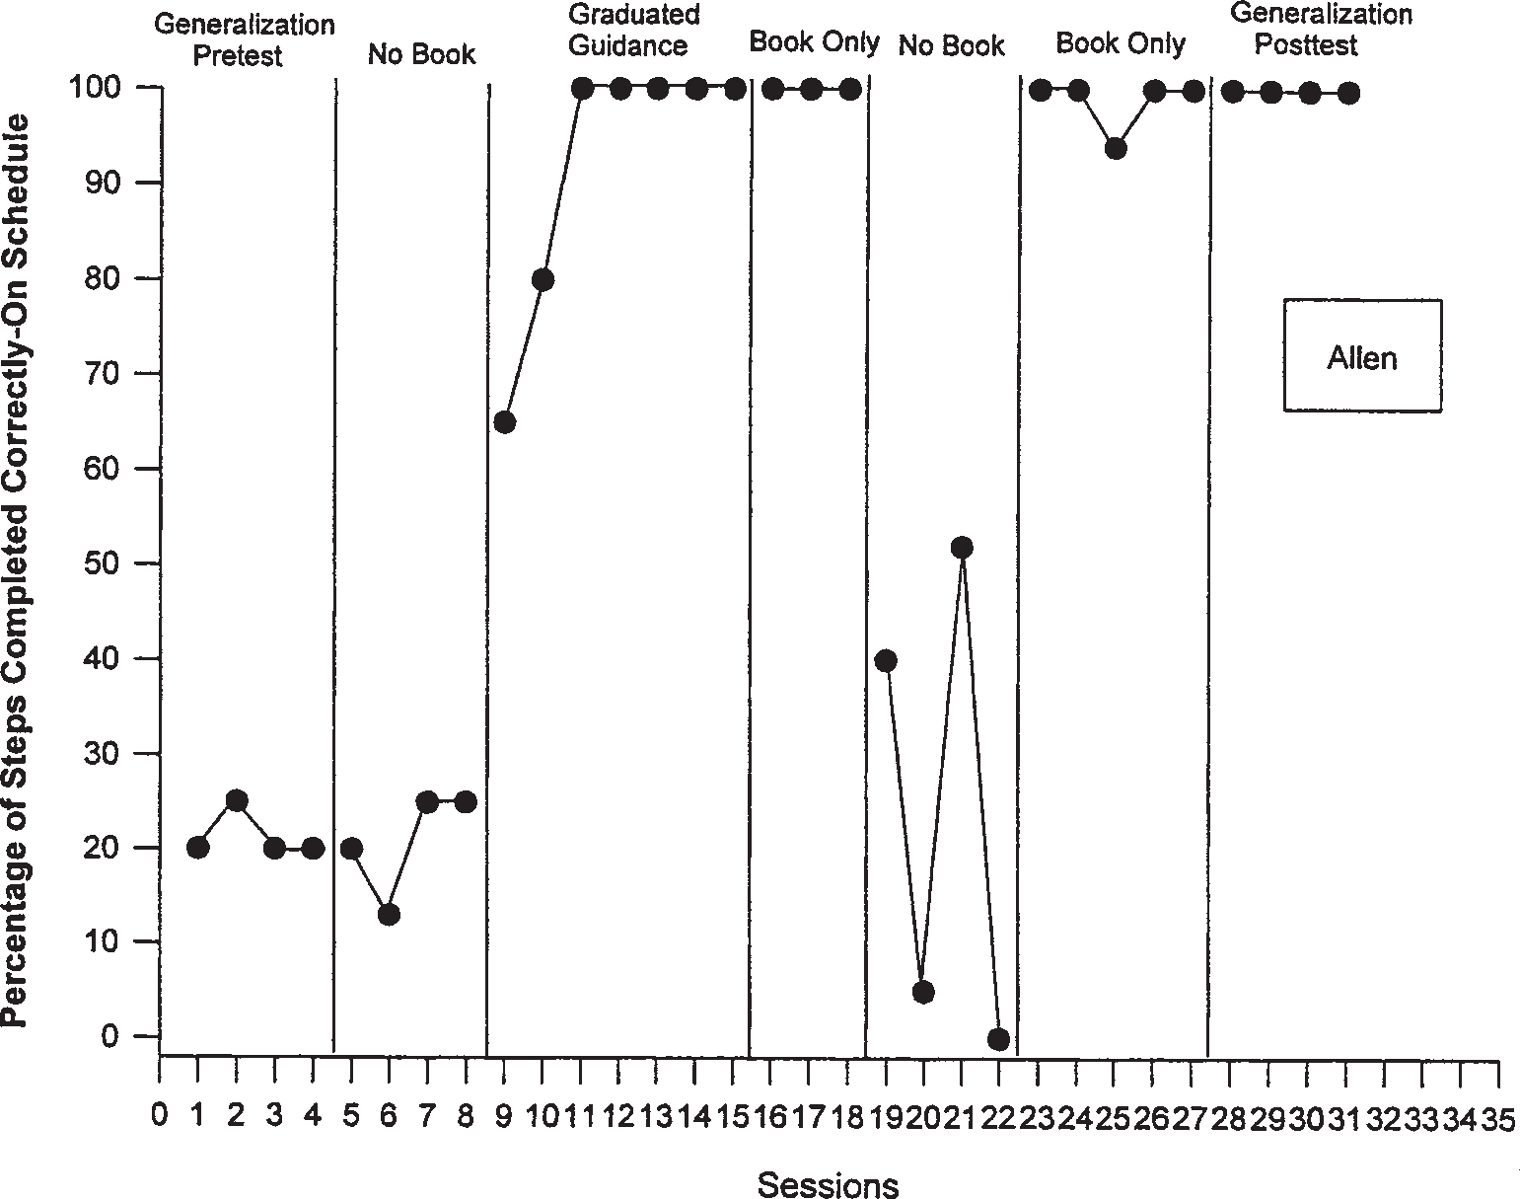

Fig. 1. The percentage of On-Schedule steps completed correctly for Allen.

Allen’s data show an abrupt change in level of steps with an accelerating trend that stabilized at 100% (range 65–100%) over five consecutive sessions. Upon introduction of the Book Only condition, performance maintained at 100% for three consecutive sessions. Upon return to the No Book condition, the mean per- centage of steps completed correctly dropped to 27.0%. Reintroduction of the Book Only condition resulted in an abrupt change in level with a mean of 98% (range 90–100%) steps completed correctly.
Tim’s on-schedule data are shown in Fig. 2. Dur- ing the first No Book condition, Tim showed a stable level and trend with a mean percentage of steps com- pleted correctly of 4.5%. Upon introduction of the Graduated Guidance condition, there was an abrupt change in the percentage of steps completed correctly at 91.3% (range 46–100%). The percentage of steps completed correctly remained stable at 100% for four consecutive sessions. Upon introduction of the Book Only condition, performance maintained at 100% for three consecutive sessions. Reintroduction of the No Book condition resulted in an abrupt change in level with the mean percentage of steps completed correctly
at 16% (range 6–25%). Upon reintroduction of the Book Only condition Tim’s performance rose to and maintained at 100% over five consecutive sessions.
Figure 3 shows Jack’s on-schedule data across the four experimental conditions. During the first No Book condition Jack’s mean percentage of steps completed correctly was 6.25%. Upon introduction of the gradu- ated guidance condition, there was an abrupt change in the percentage of steps completed correctly (range 53–100%) with an accelerating trend. The percentage of correctly completed steps remained above the 90% cri- terion level for five consecutive sessions. Performance data maintained at 100% throughout the Book Only con- dition for three consecutive sessions. Upon reintroduc- tion of the No Book condition there was an abrupt change in level with a mean percentage of correctly com- pleted steps of 4.5%. Upon reintroduction of the Book Only condition, mean performance rose to 100%.
Jenny’s on-schedule data are presented in Fig. 4. Jenny’s mean percentage of steps completed correctly was 3.25% during the first No Book condition. Upon introduction of the Graduated Guidance condition there was an accelerating trend with the percentage of steps

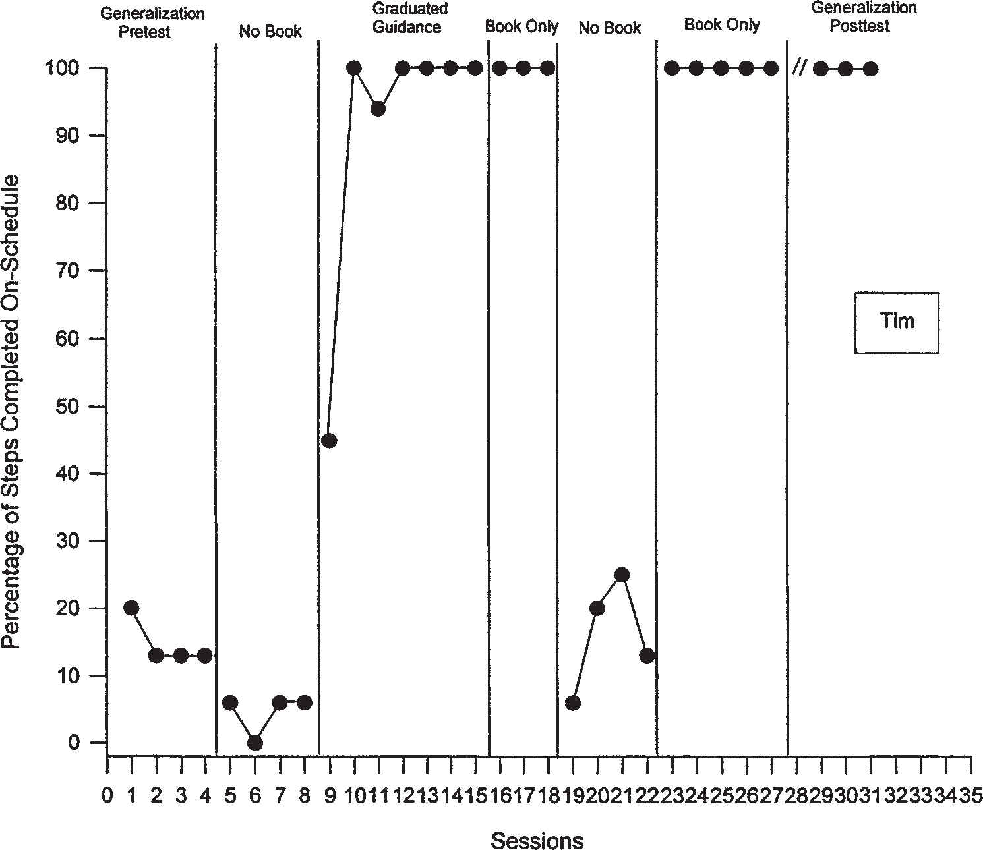

Fig. 2. The percentage of On-Schedule steps completed correctly for Tim.

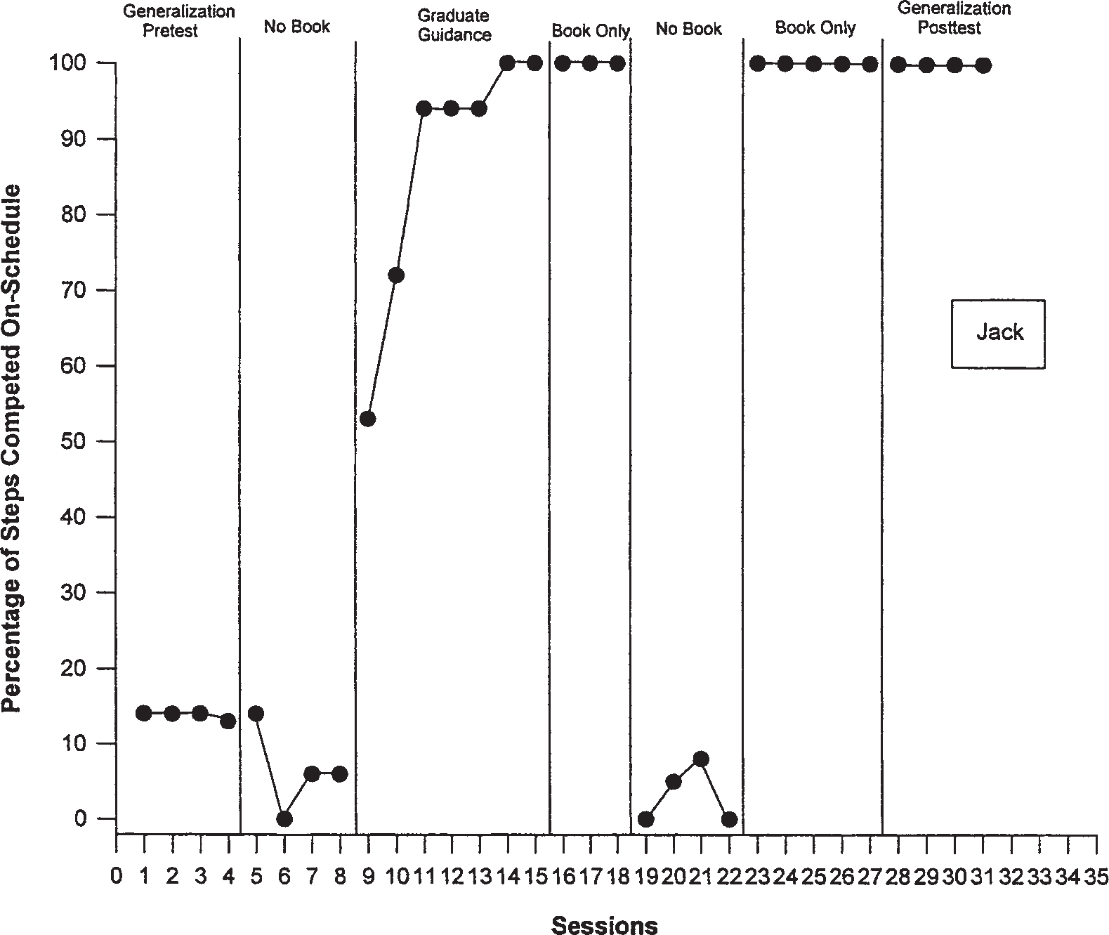

Fig. 3. The percentage of On-Schedule steps completed correctly for Jack.

completed correctly ranging from 45–100%. The per- centage of steps rose to 100% on the third session and remained at 93% for the last four sessions of the con- dition. Upon introduction of the Book Only condition performance stabilized at 100% for three consecutive sessions. Upon returning to the No Book condition the mean percentage of steps completed correctly dropped to 19%. Reintroduction of the Book Only resulted in 100% correct responding.

On-Task Data
A graphic display of the percentage of intervals on-task with scheduled materials and nonscheduled ma- terials for each student appears in Figs. 5–8. The pri- mary focus of the investigation was performance based on percentage of on-task behavior with scheduled ma- terials. Introduction of the Graduated Guidance proce- dure and the reinstatement of the Book Only condition resulted in immediate and abrupt increases in the level of performance for each student. Under conditions without the book, there was immediate decrease in the
level of on-task performance with appropriate materi- als for each student.
During the first No Book condition (baseline), Allen performed at a mean of 60.3% (range 25–65%) intervals on-task with scheduled materials (Fig. 5). A similar level of 44% (range 0–83%) was recorded dur- ing the second No Book condition. Introduction of the Graduated Guidance condition resulted in Allen’s per- formance rising to a mean of 98.4% (range 95–100%) and continued at criterion levels across the first Book Only condition with a mean of 99.3% (range 98–100%). Similar high levels of on-task behavior with scheduled materials were recorded in the second Book Only con- dition with a mean of 99.6% (range 98–100%).
Tim performed at low levels during the initial and second No Book conditions; mean = 28% (range 0–38%) and 35% (range 23–53%), respectively (Fig. 6). He immediately increased his performance upon intro- duction of the Graduated Guidance condition (M = 99%) and continued at 100% performance across the first Book Only condition. The second Book Only condition yielded a mean percentage of 99.6% performance

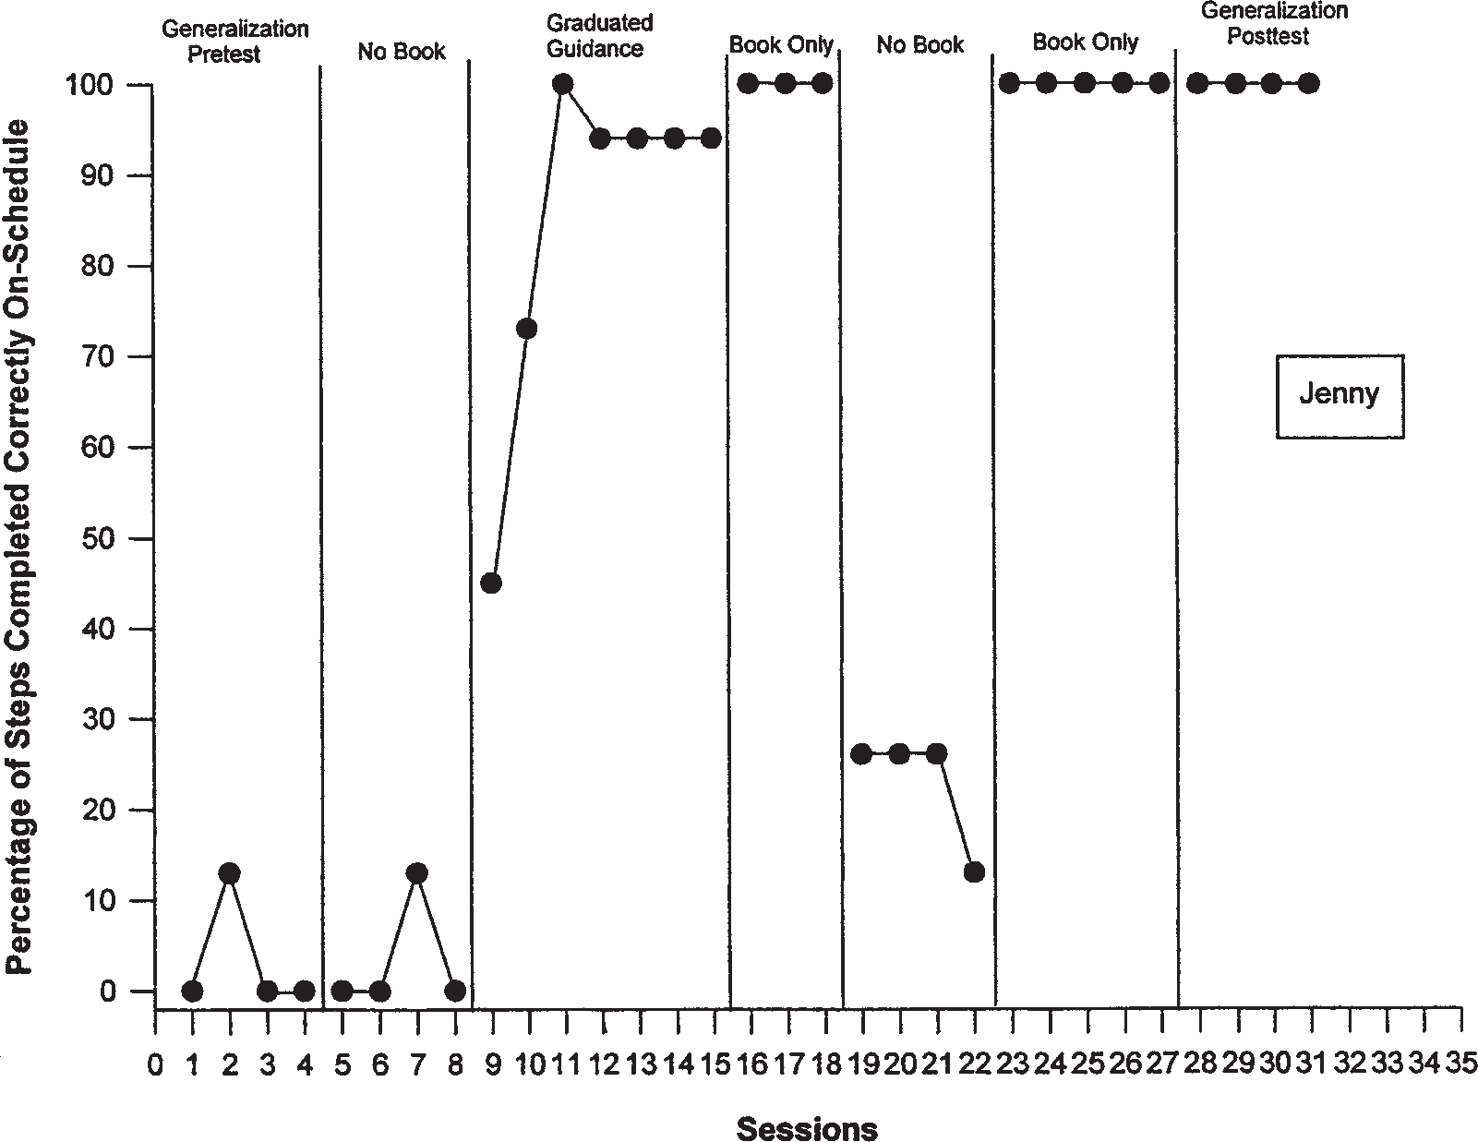

Fig. 4. The percentage of On-Schedule steps completed correctly for Jenny.

(range 98–100%). Like Allen, Tim’s on-task with non- scheduled materials decreased when on-task behavior with scheduled materials increased.
Jack and Jenny also demonstrated abrupt changes in level upon introduction of the Graduated Guidance procedure (Ms = 95.6% and 97.4%, respectively) (Figs. 7, 8). These high levels (i.e., 100%) maintained during the first and second Book Only conditions for Jack and Jenny. Jack and Jenny also decreased their on-task be- havior with nonscheduled materials behavior as they in- creased their on-task behavior with scheduled materials. In summary, the effectiveness of the graduated guid-
ance procedure in teaching students to use the picture- activity schedule books was replicated across the four participants. In addition to intersubject replication, in- trasubject replication was demonstrated with both de- pendent variables with each of the four students. Clear distinctions were established with each student between the No Book and Book Only conditions.

Efficiency
The efficiency results are based on data collected from the the graduated guidance condition. For sessions
to criterion, the mean was 5.25 with a range from 5 to 6. Mean time to criterion was 210 minutes with a range from 200 to 240 minutes. The mean number of prompts to criterion was 8.75, ranging from 5 to 14. There were no teacher prompts delivered during the Book Only and No Book conditions.

Generalization Data
Each student’s generalization data of on-schedule and on-task behaviors to novel activity schedules using the book are presented in Figs. 1–8. During the general- ization pretest condition, all students’ mean performance of on-schedule behaviors was low (range 3.3–21.5%). During the generalization posttest condition all students’ mean performance increased to 100% for 4 consecutive days. Similarly, student mean performance of on-task behavior with appropriate materials maintained at low levels during the generalization pretest condition (range 5–31.5%). Generalization posttest condition measures yielded increases in performance to 100% for Allen, Tim, and Jack for four consecutive days, while Jenny’s mean percentage of intervals on-task with appropriate items during the generalization posttest condition was 99.5%

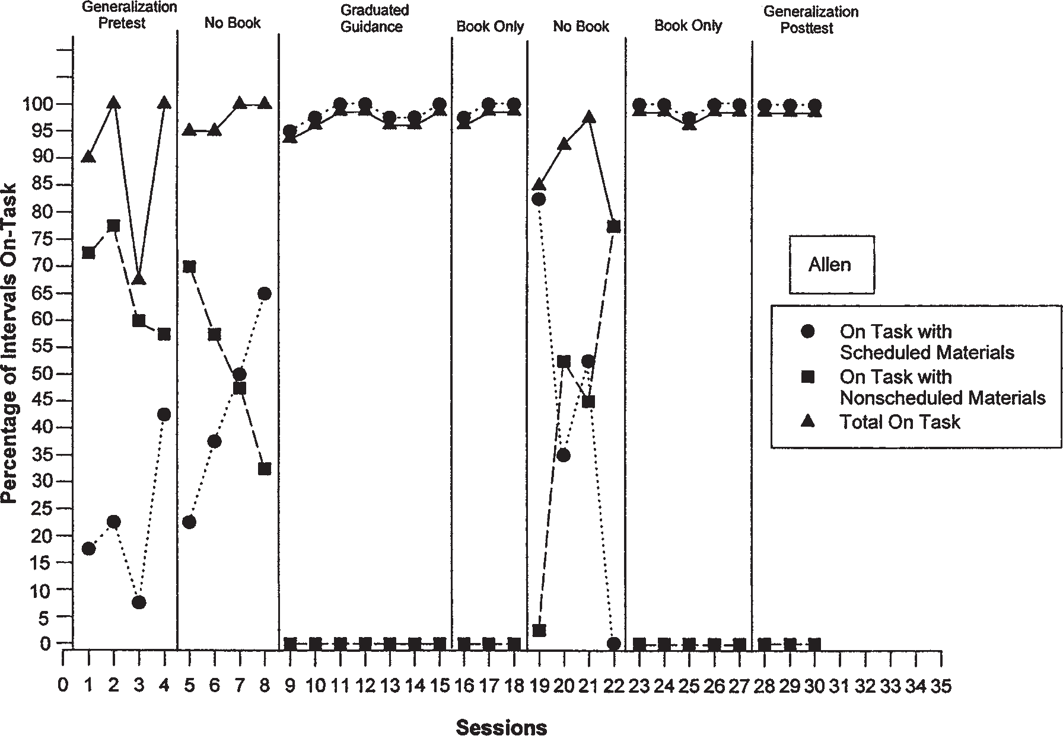

Fig. 5. The percentage of on-task performance intervals for Allen. Triangles indicate on-task behavior with appropriate materials. Squares indicate on-task behavior with inappropriate materials. Circles indicate total on-task behavior.

(range 98–100%). In summary, intrasubject replication was demonstrated across the four participants showing that the effects of the graduated guidance instruction and the use of the activity-schedule book were not restricted to the activities scheduled during training, but general- ized across novel activity schedules.

Social Validity
The social validity questionnaire was completed by the students’ general classroom teachers, speech and language pathologists, and paraprofessionals. Questions were scored using a Likert scale format ranging from 1 (strongly disagree) to 5 (strongly agree). Table II pre- sents the mean score for each child. Question 1 indi- cated that raters were equally divided in their belief that the picture schedule was responsible for students’ learn- ing (M = 3.6). It was agreed that picture schedules pro- moted student independence (M = 4.9). The feasibility of using a picture schedule in various classrooms was agreed upon (M = 4.1). There was also disagreement on whether students with autism could only learn if they had a one-on-one teacher who constantly prompted them (M = 2.3). Questions 5 and 6 show agreement that
picture schedules can be used for all students (M = 4.6) and that they are a useful classroom tool (M = 4.8). Fi- nally, there was a consistent change of opinion since these people observed the students with autism work- ing independently (M = 4).

DISCUSSION

The purpose of this study was to evaluate the ef- fectiveness of a two-component teaching package (grad- uated guidance procedure and picture-activity schedule) in teaching students with autism to engage in on-task and on-schedule behaviors. This investigation provides support for the development and use of a visual activ- ity schedule for students with high-functioning autism. The results of the present study support the findings of MacDuff et al. (1993) in the following ways: (a) stu- dents quickly learned the mechanics of the picture- activity schedule via the graduated guidance procedure which was then easily faded; (b) students maintained high levels of independent on-task and on-schedule behaviors with the picture book alone; and (c) high levels of on-task behavior with appropriate scheduled

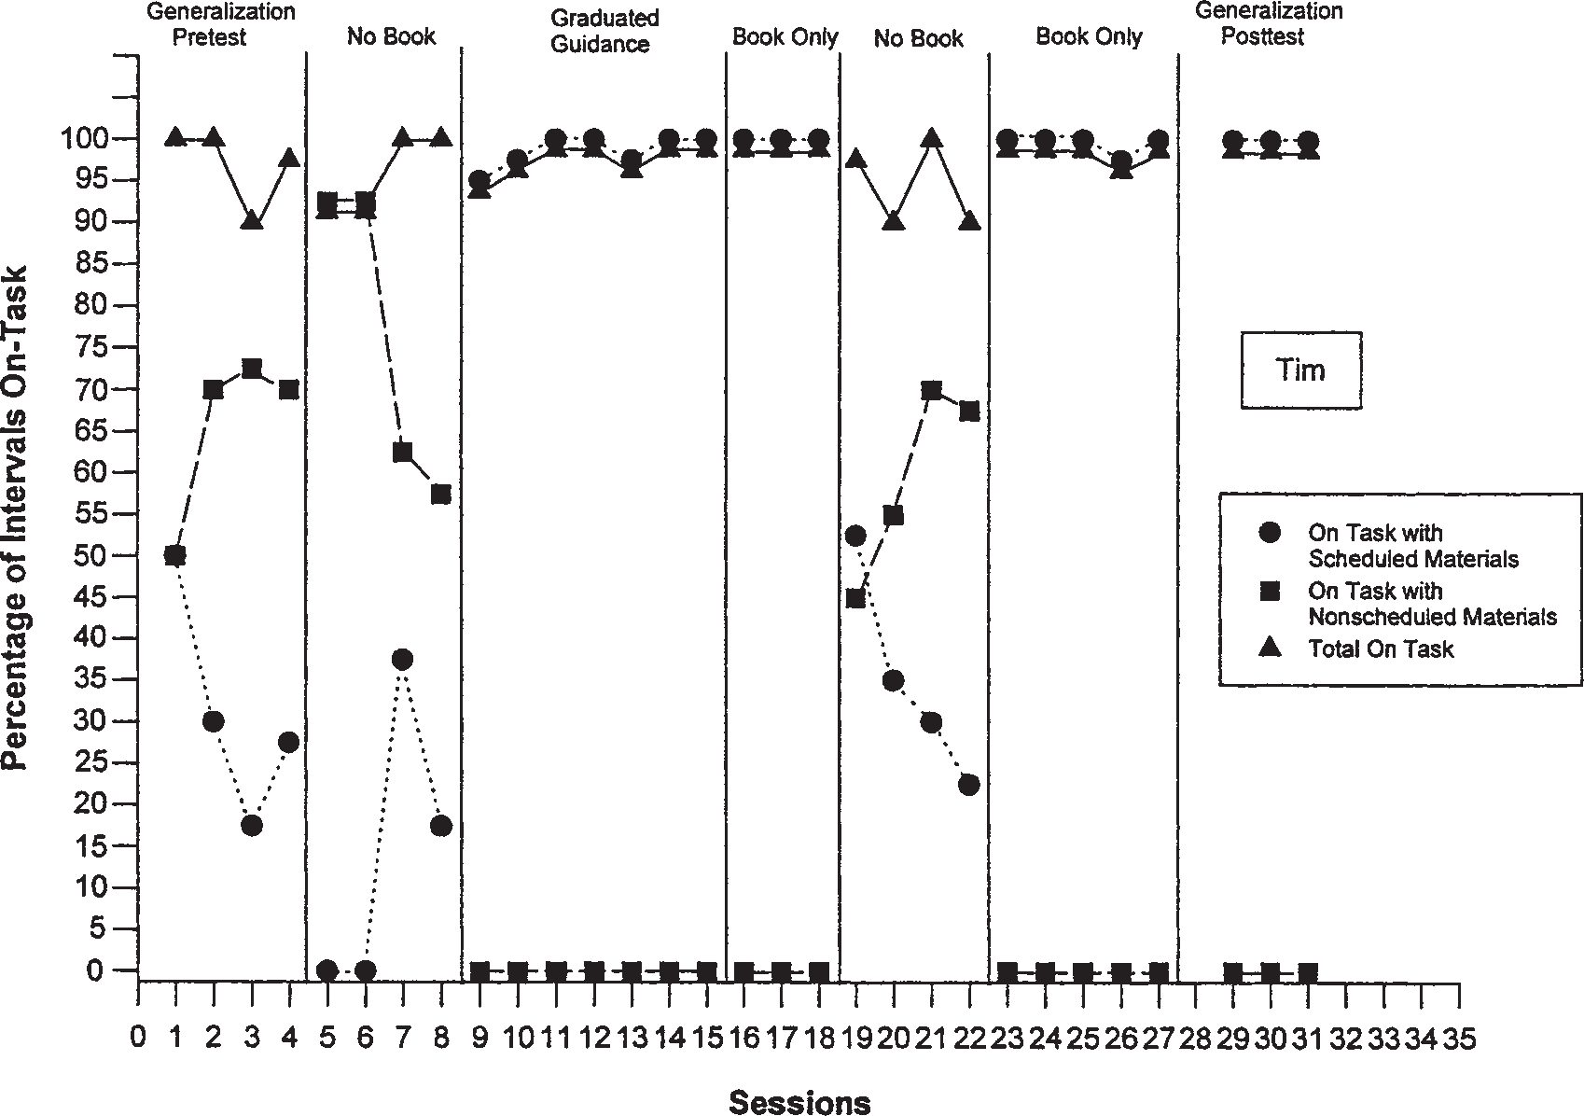

Fig. 6. The percentage of on-task performance intervals for Tim. Triangles indicate on-task behavior with appropriate materials. Squares in- dicate on-task behavior with inappropriate materials. Circles indicate total on-task behavior.

materials correlated with a decrease in nonscheduled behaviors.
This study also addressed whether the percentage of on-task and on-schedule behaviors would general- ize to novel activities. Current results support the find- ings of previous investigations (MacDuff et al., 1993; Pierce & Schriebman, 1994; Wacker & Berg, 1983) in which generalization to novel tasks was attained with minimal or no extra training. It is possible that the ran- dom presentation of the stimuli (pictures) during each session throughout the investigation fostered this gen- eralization. Stimulus control was then easily transferred to the picture book alone for each activity sequence and each novel activity.
There were differences between the MacDuff et al. (1993) investigation and the current investigation which extend the findings of the literature. First, the partici- pants in the previous investigation were older boys (ages 9–14) with low-functioning autism who were taught in a group-home setting. The participants in the current in- vestigation were younger school-age children (ages 7–8) who were taught in their local elementary school. In ad- dition, the MacDuff et al. investigation targeted leisure and homework skills whereas the current investigation
focused on literacy-based skills. As more children with autism and related disorders are being served in their local schools, it is imperative that these programs run efficiently. Because school-age children with autism are being faced with new learning environments and a lack of consistent routines in these settings (Cohen & Volk- mar, 1997), picture schedules may provide a way for them to engage in appropriate task-related behaviors with minimal adult prompting.
Another finding of the current study deals with the interaction between students during a few of the ob- servational periods after the graduated guidance con- dition. For the most part, students were working on their own tasks. It was noted, however, that Allen and Jack would occasionally prompt Jenny if she was not following her schedule correctly. Jenny typically re- sponded, “Oh yeah,” and resumed appropriate on-task and on-schedule behaviors. These interactions were not prompted by an adult. This is an excellent example of how the picture-schedule system may have encouraged positive interactions between students with autism. Al- though some may view these interactions between stu- dents as a confounding variable, others may view this as a positive side effect of the picture schedule system.

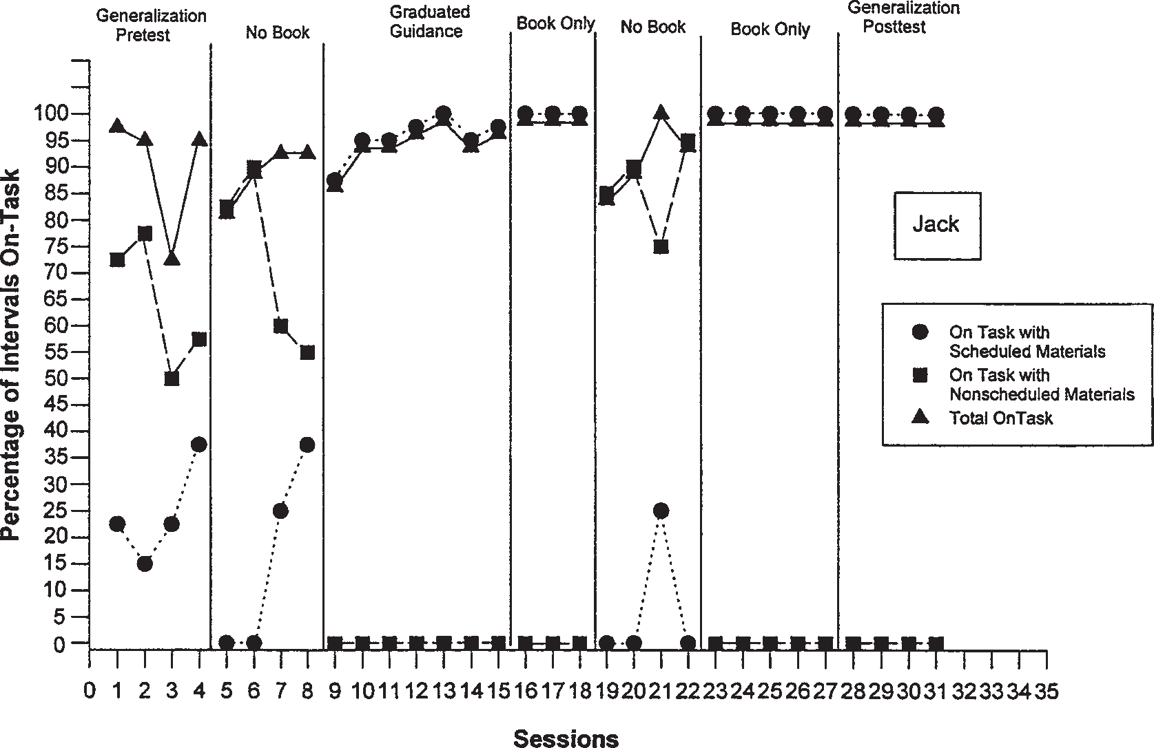

Fig. 7. The percentage of on-task performance intervals for Jack. Triangles indicate on-task behavior with appropriate materials. Squares in- dicate on-task behavior with inappropriate materials. Circles indicate total on-task behavior.

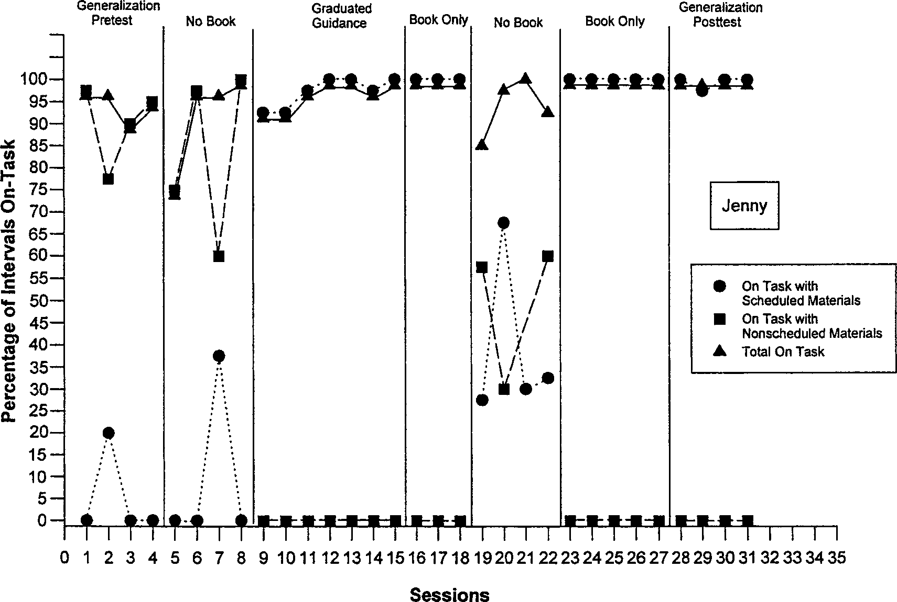

Fig. 8. The percentage of on-task performance intervals for Jenny. Triangles indicate on-task behavior with appropriate materials. Squares indicate on-task behavior with inappropriate materials. Circles indicate total on-task behavior.

Table II. Social Validity Questionnaire: Mean Score (range) Per Questiona
Studentsb

Allen Tim Jack Jenny
(3) (3) (3) (3)
Mean
Question M (Range) M (Range) M (Range) M (Range) response
  - This child really learned academic 2.5 (2–3) 4 (3–4) 4 (2–4) 4 (3–4) 3.6
skills using the picture schedules.
  - This child became more independent 4.5 (4–5) 5 (5–5) 5 (5–5) 5 (5–5) 4.9
while using the picture schedules
  - Implementing a picture schedule in my 4 (4–4) 4 (4–4) 4 (4–4) 4.5 (4–5) 4.1
my classroom would be feasible.
4. This child can only learn if  they have a one on one teacher. | 2 | (1–3) | 2.5 | (1–3) | 2.5 | (1–3) | 2 | (2–2) | 2.3
5. Picture schedules can be used for | 4.5 | (4–5) | 4.5 | (4–5) | 4.5 | (4–5) | 5 | (5–5) | 4.6

all children.
6. Picture schedules are a useful 5 (5–5) 4.5 (4–5) 4.5 (4–5) 5 (5–5) 4.8
management tool.
7. My opinions have changed since I have 4 (3–5) 4 (4–4) 4 (3–5) 4 (4–4) 4
observed this child using a schedule.
a 1 = strongly disagree; 2 = disagree; 3 = neutral; 4 = agree; 5 = strongly agree.
b No of respondents = 3 for each student.

Whichever position one ascribes to, future research on the effects of picture schedules on children’s sponta- neous social interaction and observational learning is worthy of investigation.
Social validity findings indicate that the students’ regular education teachers, paraprofessionals, and speech teachers reported that using picture schedules would be a useful management tool, would be feasible to imple- ment in their classrooms, and could be used to benefit all children. As well, they stated that the students be- came more independent using the picture schedules. Prior to this investigation all four students were depen- dent upon adult prompting during literacy-based activi- ties. After this investigation, Jack asked for a schedule to be used during math time. In addition, Tim and Allen asked if they could continue using their schedules dur- ing their language arts time. These requests exemplify the motivation and enthusiasm that students with autism can demonstrate when given the appropriate tools. Fu- ture research should focus on the use of visual prompt- ing systems to increase on-task and on-schedule behav- iors for students with high-functioning autism in other integrated subject areas (math, science, social studies). Whether a student’s least restrictive environment is a general classroom, a resource classroom, or a self- contained classroom, research could be expanded in the future by evaluating the effects of a visual prompt- ing systems used throughout the day in a classroom set- ting serving students with autism spectrum disorders. Finally, future research could explore the possibilities of
“blending” these schedules into the environment by hav- ing them displayed in notebooks, As well, for those stu- dents with autism who can read, written schedules could be placed in calendars or day planners.

ACKNOWLEDGMENTS

This study was based on an applied project com- pleted by the first author in partial fulfillment of the requirements for an M.Ed. degree in the Department of Special Education at the University of Georgia. The au- thors are indebted to the assistance provided by Kent Logan, Department of Special Education, Kennesaw State University; Cindy Vail, Department of Special Education, University of Georgia; and Deanna M. Luscre, Department of Special Education, Gwinnett County Schools.

REFERENCES

American Psychological Association. (1994). Diagnostic and statis- tical manual of mental disorders (4th ed.). Washington, DC: Author.
Billingsley, F. F., White, O. R., & Munson, R. (1980). Procedural reliability: A rationale and an example. Behavioral Assessment, 2, 229–241.
Bondy A. S., & Frost, L. A. (1994) The Picture Exchange Commu- nication System. Focus on Autistic Behavior, 9, 1–18.
Carson, P., & Dellosa, J. (1991). Fabulous file folder games. Greens- boro, NC: Carson-Dellosa Publishing.
Carson, P., & Dellosa, J. (1997). Let’s learn . . . the big book.
Greensboro, NC: Carson-Dellosa Publishing.

Cohen, D. J., & Volkmar, F. R. Handbook of autism and pervasive developmental disorders (2nd ed.). New York: Wiley.
Connis, R. T. (1979) . The effects of sequential pictorial cues, self recording, and praise on the job task sequencing of retarded adults. Journal of Applied Behavior Analysis, 12, 355–361.
EBSCO Curriculum Materials. (1985). The sensible pencil : A hand- writing program. Birmingham, AL: Author.
Frank, A. R., Wacker, D. P., Berg, W. K., & McMahon, C. M. (1985). Teaching selected microcomputer skills to retarded students via picture prompts. Journal of Applied Behavior Analysis, 18, 179–185.
Frost, L., & Bondy, A. (1994). The picture exchange communication system training manual. Cherry Hill, NJ: PECs.
Hall, L. J., McClannahan, L. E., & Krantz, P. J. (1995). Promoting independence in integrated classrooms by teaching aides to use activity schedules and decreased prompts. Education and Train- ing in Mental Retardation and Developmental Disabilities, 30, 208–217.
Hodgdon, L. A. (1995). Visual strategies for improving communi- cation. Troy, MI: Quirk Roberts.
Johnson, B. F., & Cuvo, A. J. (1981). Teaching mentally retarded adults to cook. Behavior Modification, 5, 187–202.
Johnson, B. F., & Cuvo, A. J. (1991). Teaching mentally retarded adults to cook. Behavior Modification, 15, 187–202.
Jolly, A. C., Test, D. W., & Spooner, F. (1993). Using badges to in- crease initiations of children with severe disabilities in a play setting. Journal of the Association for Persons with Severe Handicaps, 18, 46–51.
Kaufman, A. S., & Kaufman, N. L. (1985). Kaufman test of educational achievement. Circle Pines, MN; American Guidance Service.
Koegel R. L., & Koegel, L. K. (1995). Teaching children with autism: Strategies for initiating positive interactions and improving learning opportunities. Baltimore, MD: Paul H. Brookes.
Krantz, P. J., MacDuff, M. T., & McClanahan, L. E. (1993). Pro- gramming participation in family activities for children with autism: Parent’s use of photographic activity schedules. Jour- nal of Applied Behavior Analysis, 26, 137–138.
MacDuff, G. S., Krantz, P. J., & McClanahan, L. E. (1993). Teach- ing children with autism to use photographic activity schedules: Maintenance and generalization of complex response chains. Journal of Applied Behavior Analysis, 26, 89–97.
Martin, J. E., Elias-Burger, S., & Mithaug, D. E. (1987). Acquisition and maintenance of time-based task change sequence. Educa- tion and Training in Mental Retardation, 22, 250–255.
Martin, J. E., Mithaug, D. E., & Frazier, E. S. (1992). Effects of pic- ture referencing on PVC chair, love seat, and settee assemblies by students with mental retardation. Research in Developmen- tal Disabilities, 13, 276–286.
Martin, J. E., & Rusch, F. R. (1987). Use of the partial-sequential withdrawal design to assess maintenance of mentally retarded adults’ acquired meal preparation skills. Research in Develop- mental Disabilities, 8, 389–399.
Martin, J. E., Rusch, F. R., James, V. L., Decker, P. J., & Trtol, K. A. (1982). The uses of picture cues to establish self-control in the preparation of complex meals by mentally retarded adults. Ap- plied Research in Mental Retardation, 3, 105–119.
Mechling, L. C., & Gast D. L. (1997). Combination audio/visual self- prompting system for teaching chained tasks to students with intellectual disabilities. Education and Training in Mental Re- tardation, 32, 138–153.
Nietupski, J., Welch, J., & Wacker, D. (1983). Acquisition, mainte- nance, and transfer of grocery item purchasing skills by mod- erately and severely handicapped students. Education and Train- ing of the Mentally Retarded, 18, 279–286.
Pierce, K. L., & Schriebman, L. (1994). Teaching daily living skills to children with autism in unsupervised settings through picto- rial self-management. Journal of Applied Behavior Analysis, 27, 471– 481.
Psychological Corporation. (1992). Wechsler Individual Achievement Test. San Antonio, TX: Author.
Robinson-Wilson, M. A., Bellamy, G. T., & Clark, G. (1977). Pic- ture recipe cards as an approach to teaching severely and pro- foundly retarded adults to cook. Education and Training of the Mentally Retarded, 12, 69–73.
Schopler, E., & Mesibov, G. B. (1994). Behavioral issues in autism.
New York: Plenum Press.
Schopler, E., Mesibov, G. B., & Hearsey, K. (1995). Structured teach- ing in the TEACCH system. In Schopler, E. & Mesibov, G. (Eds.), Learning and cognition in autism (pp. 243–267). New York: Plenum Press.
Schopler, E., Mesibov, G. B., & Kunce, L. J. (1998). Asperger syn- drome or high-functioning autism? New York: Plenum Press.
Schuster, J. W., & Griffen, A. K. (1993). Teaching a chained task with a simultaneous prompting procedure. Journal of Behav- ioral Education, 3, 299–315.
Sowers, J. A., Verdi, M., Bourbeau, P., & Sheehan, M. (1985). Teach- ing job independence and flexibility to mentally retarded stu- dents through the use of a self-control package. Journal of Ap- plied Behavior Analysis, 18, 81–85.
Sparrow, S. S., Balla, D. A., & Cicchetti, D. V. (1985). Vineland Adaptive Behavior Scale—Classroom Edition. Circle Pines, MN: American Guidance Services.
Stromer, R., Mackay, H. A., McVay, A. A., & Fowler, T. (1998). Written lists as a mediating stimuli in the matching-to-sample performances of individuals with mental retardation. Journal of Applied Behavior Analysis, 31, 1–19.
Tawney, J. W., & Gast, D. L. (1984). Single subject research in spe- cial education. Columbus, OH: Merrill.
Thinesen, P. J., & Bryan, A. J. (1981). The use of sequential picto- rial cues in the initiation and maintenance of grooming behav- iors with mentally retarded adults. Mental Retardation, 19, 247–250.
Wacker, D. P., & Berg, W. K. (1983). The effects of picture prompts on the acquisition of complex vocational tasks by mentally re- tarded adolescents. Journal of Applied Behavior Analysis, 16, 417– 433.
Wacker, D. P., Berg, W. K., Berrie, P., & Swatta, P. (1985). Gener- alization and maintenance of complex skills by severely hand- icapped adolescents following picture prompt training. Journal of Applied Behavior Analysis, 18, 329–336.
Wolery, M., Ault, M. J., & Doyle, P. M. (1992). Teaching students with moderate to severe disabilities. White Plains, NY: Longman.

Copyright of Journal of Autism & Developmental Disorders is the property of Kluwer Academic Publishing and its content may not be copied or emailed to multiple sites or posted to a listserv without the copyright holder's express written permission.
However, users may print, download, or email articles for individual use.

Copyright of Journal of Autism & Developmental Disorders is the property of Springer Science & Business Media B.V. and its content may not be copied or emailed to multiple sites or posted to a listserv without the copyright holder's express written permission. However, users may print, download, or email articles for individual use.

